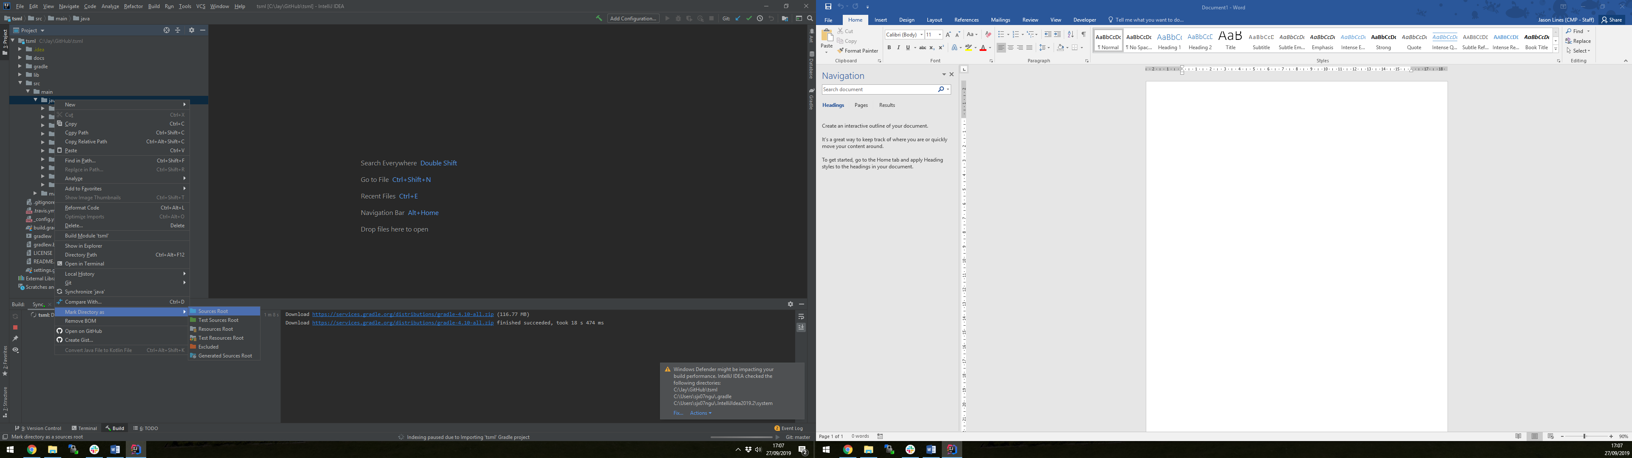

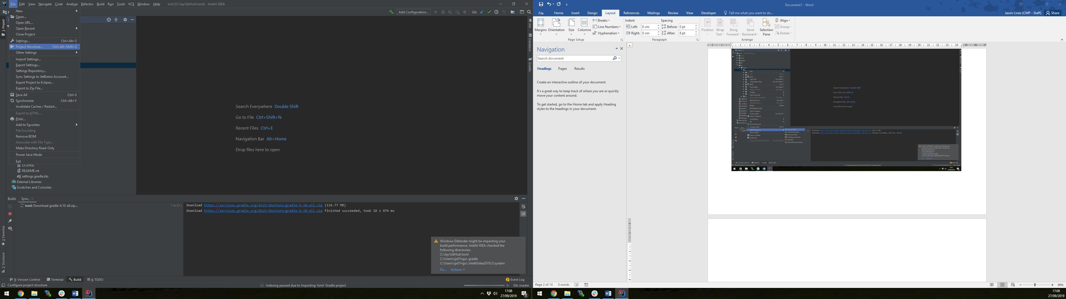

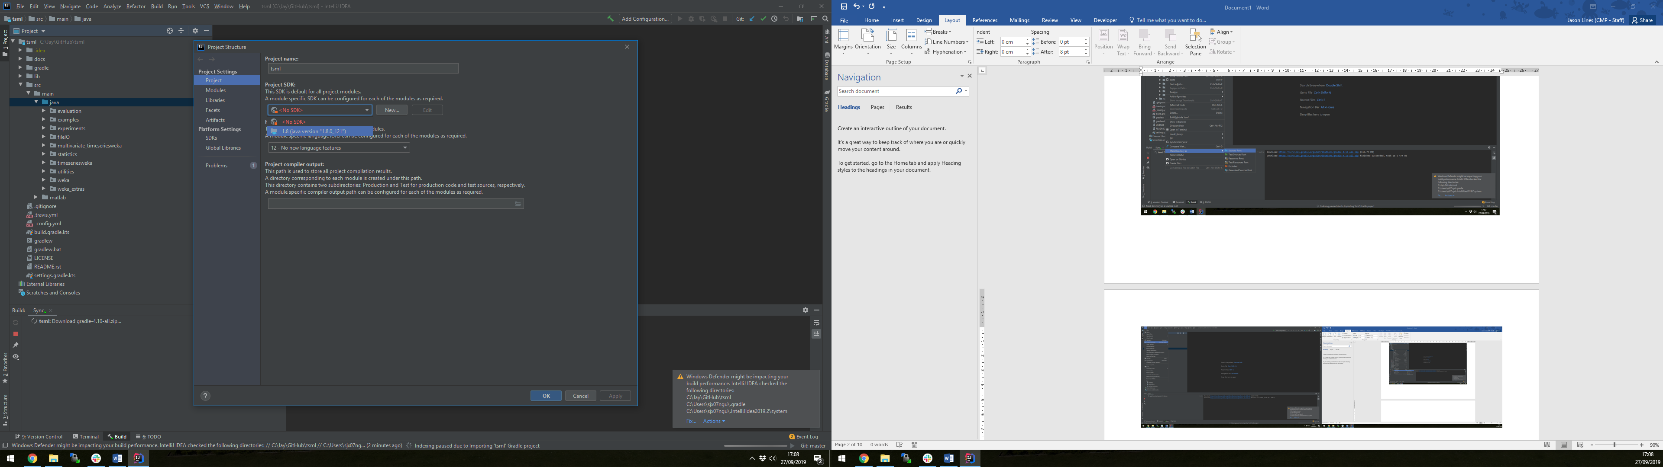

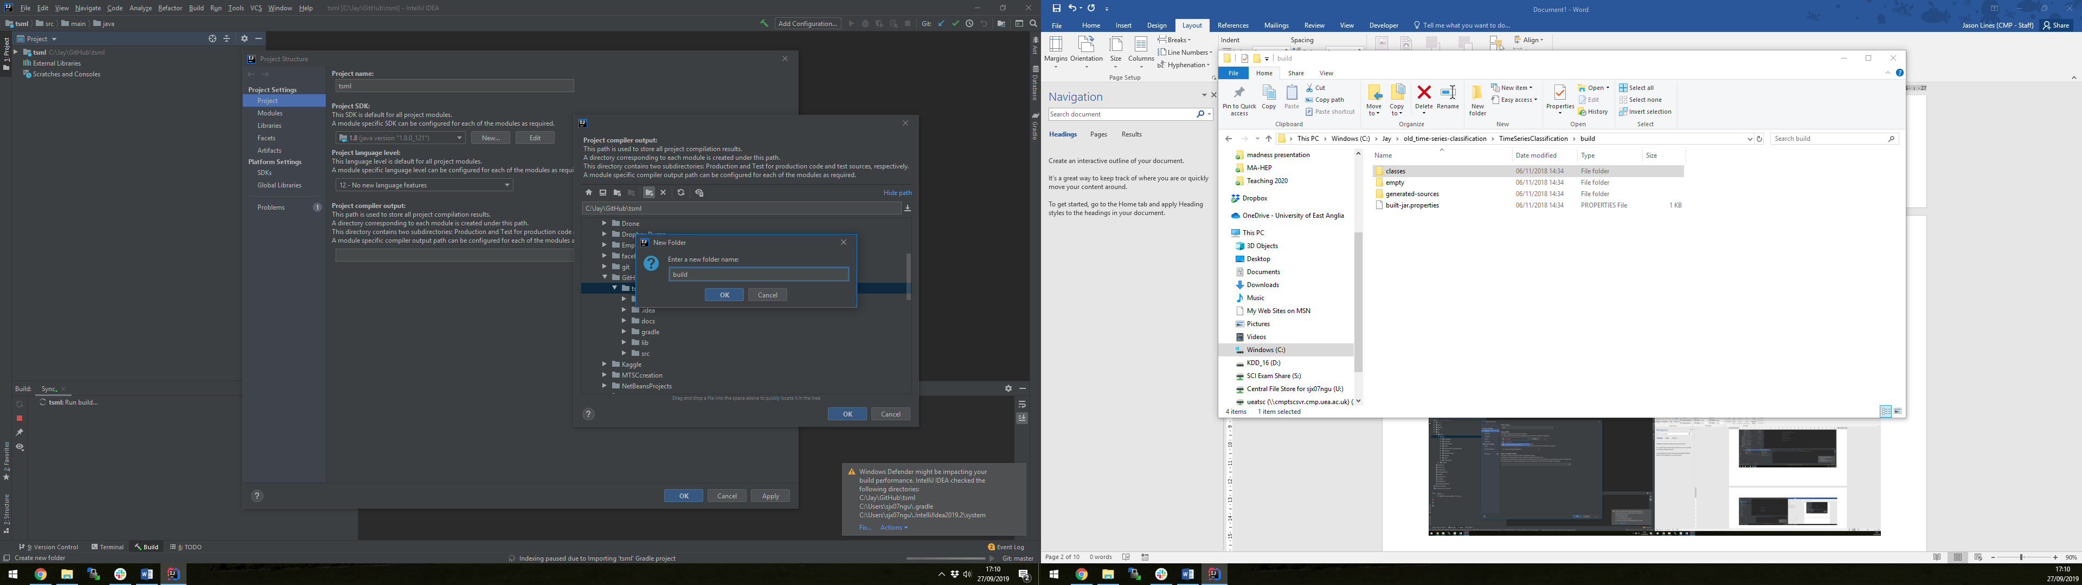

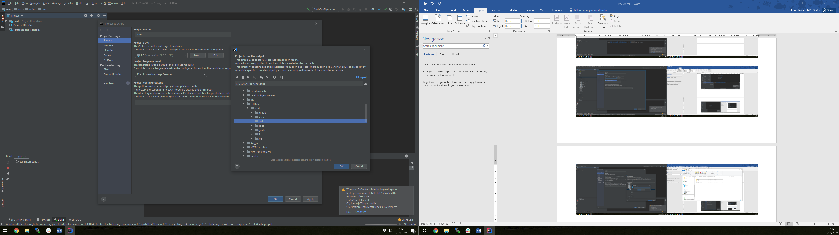

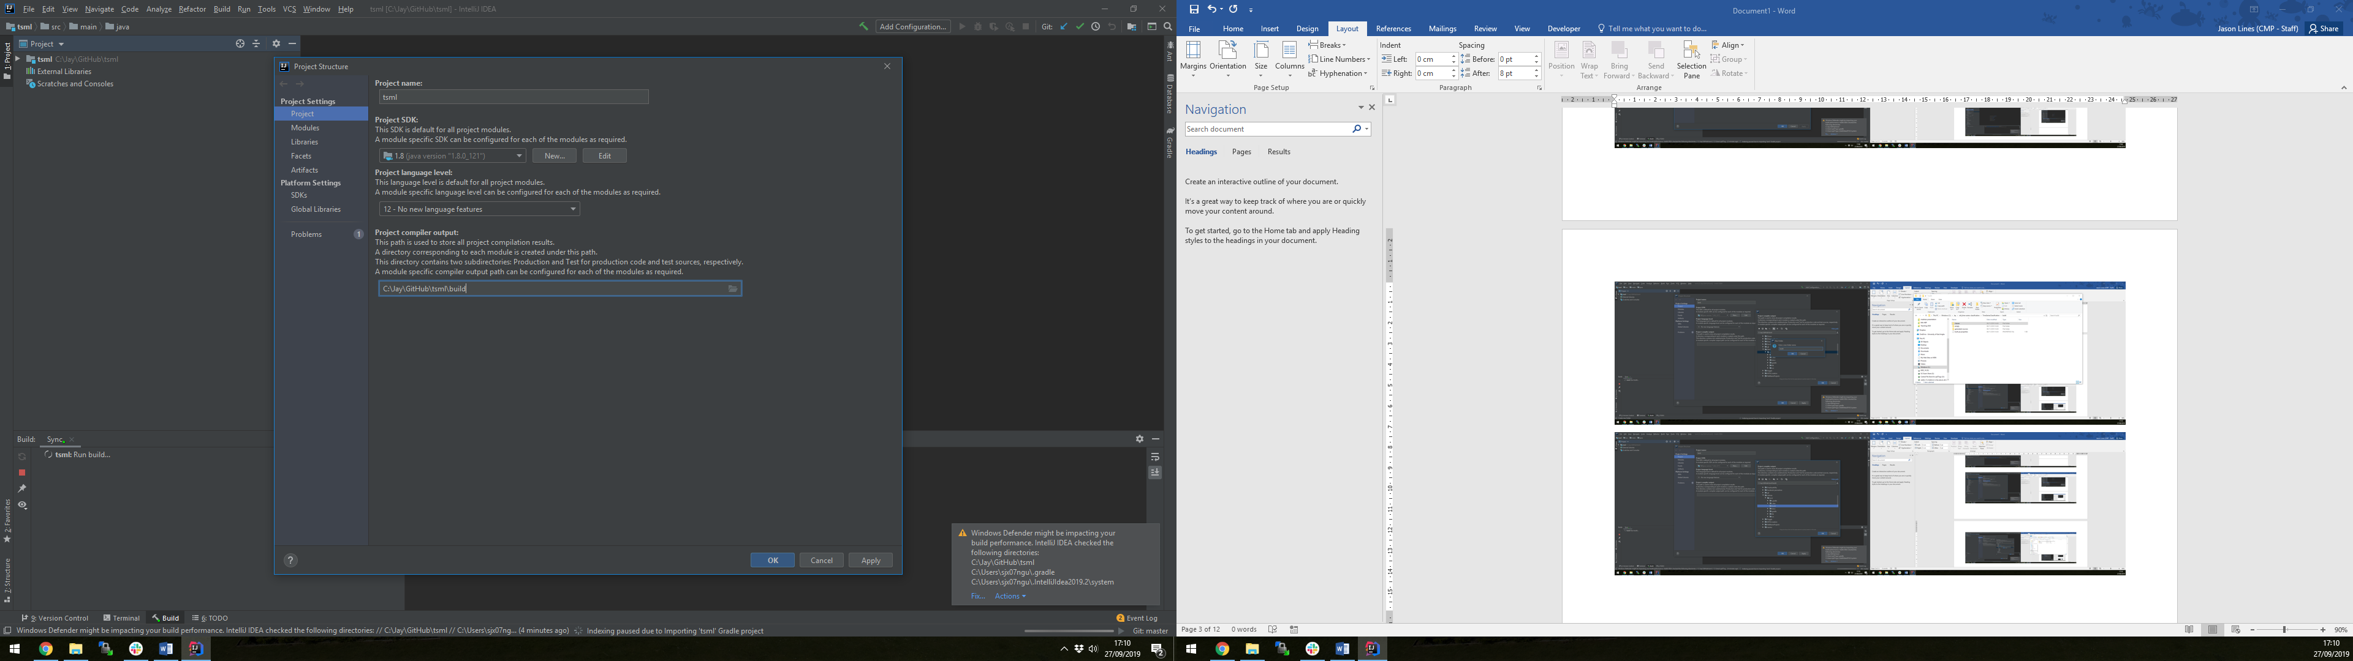

(press OK)

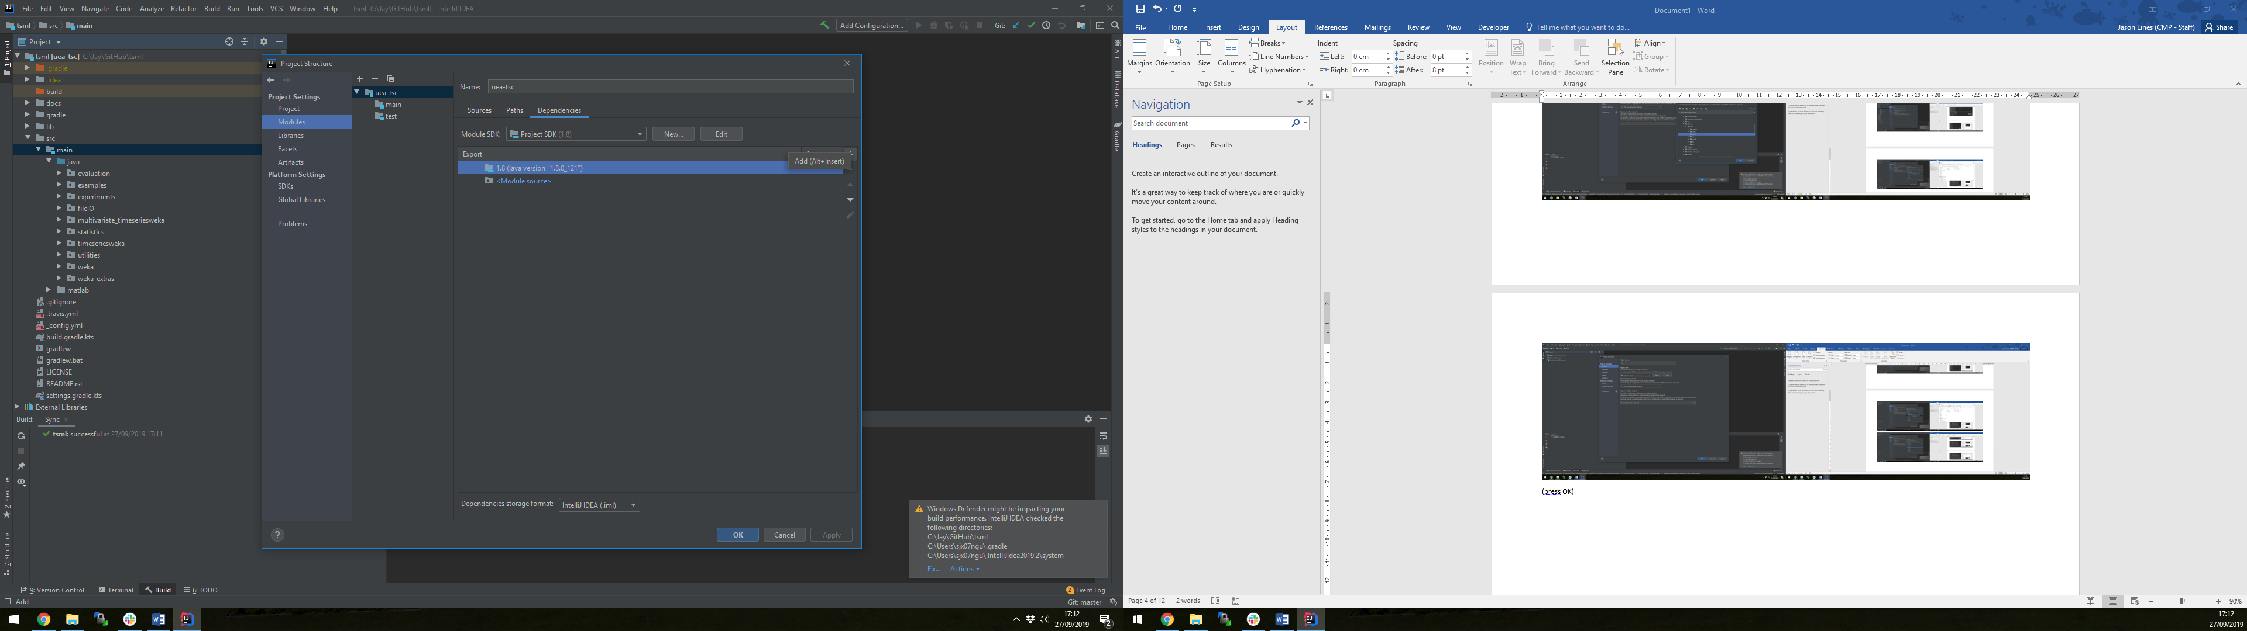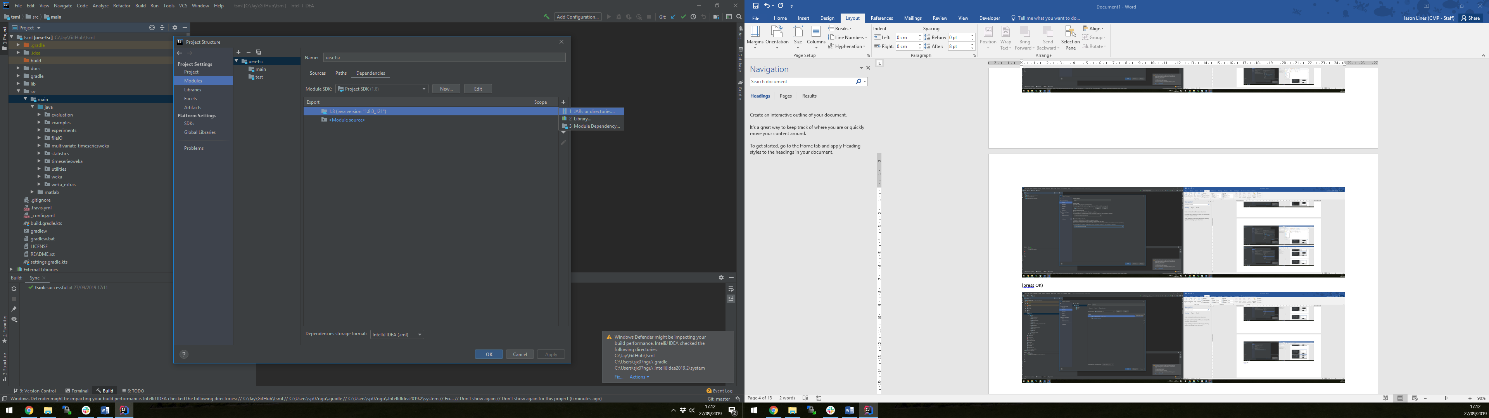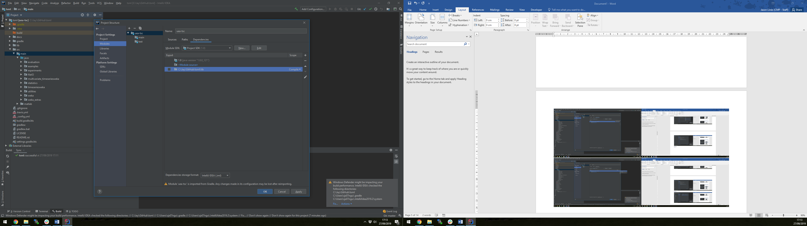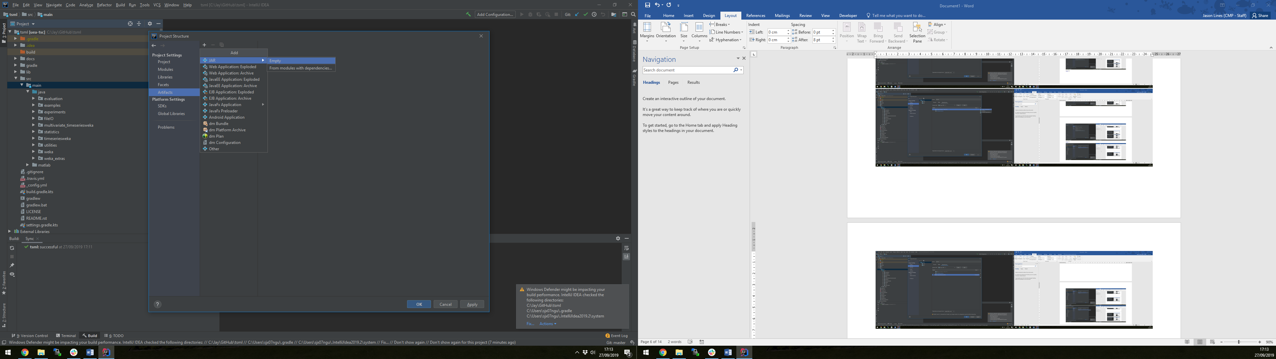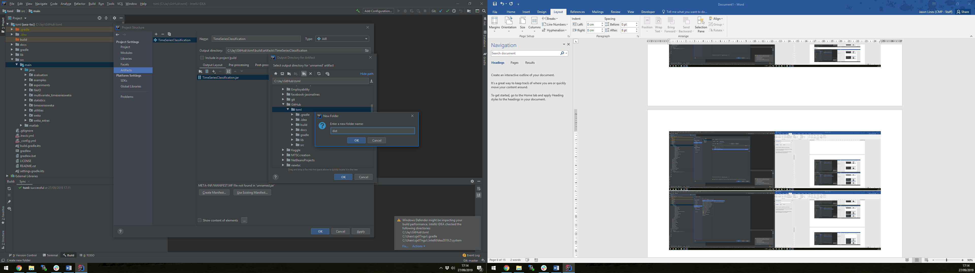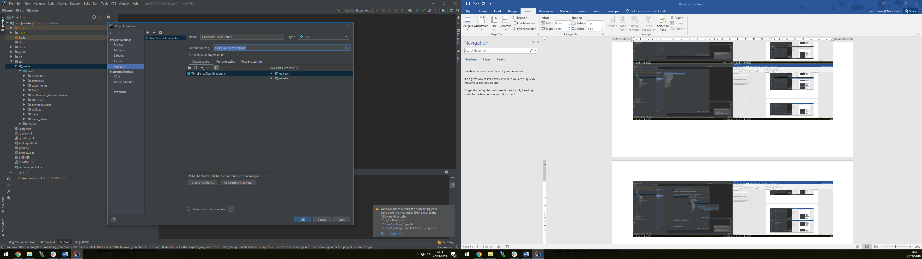

(create manifest)

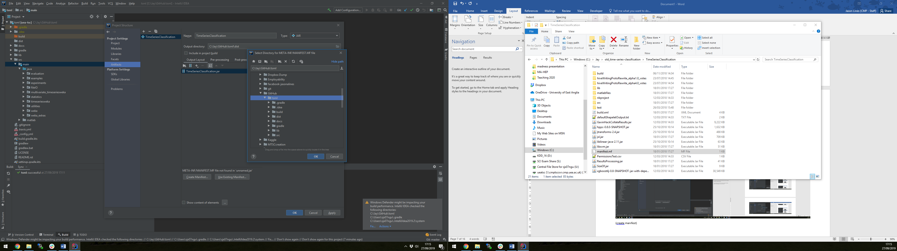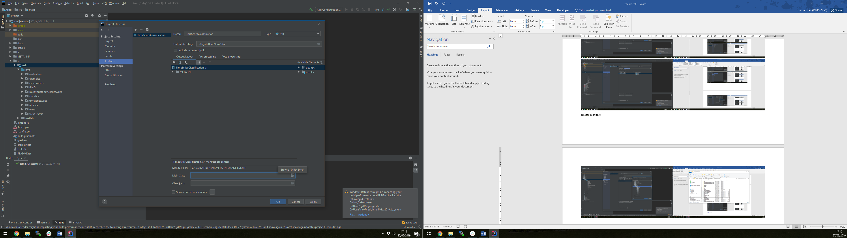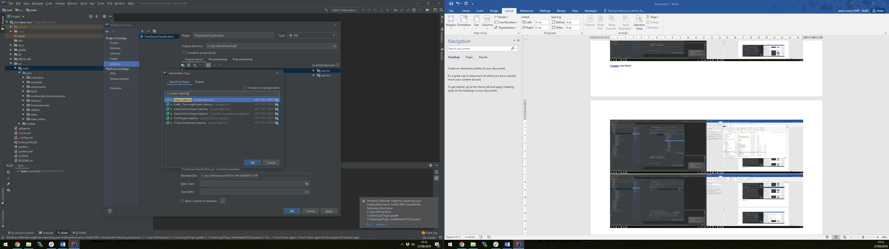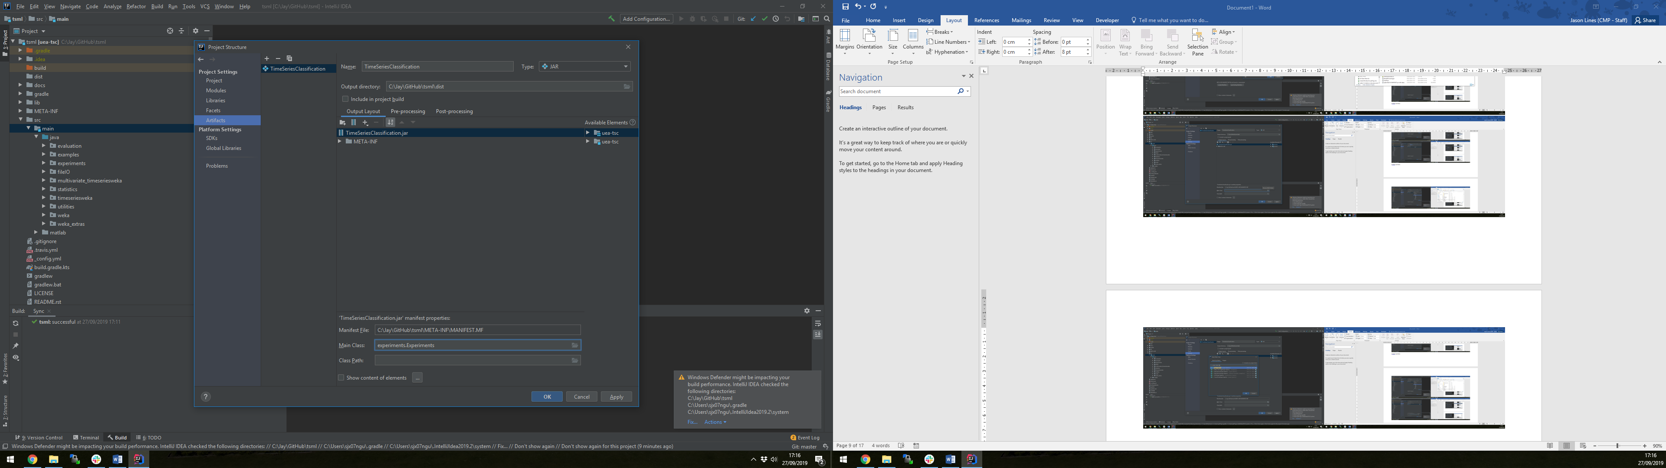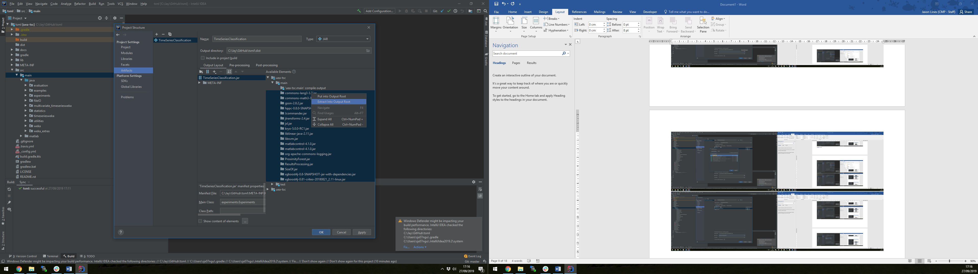(after extract)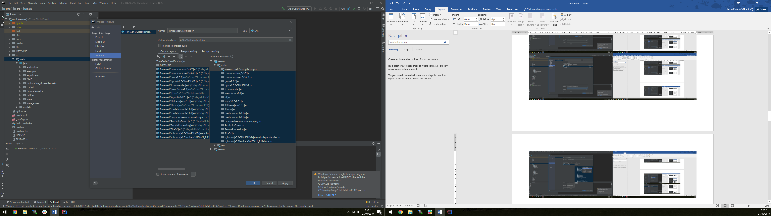

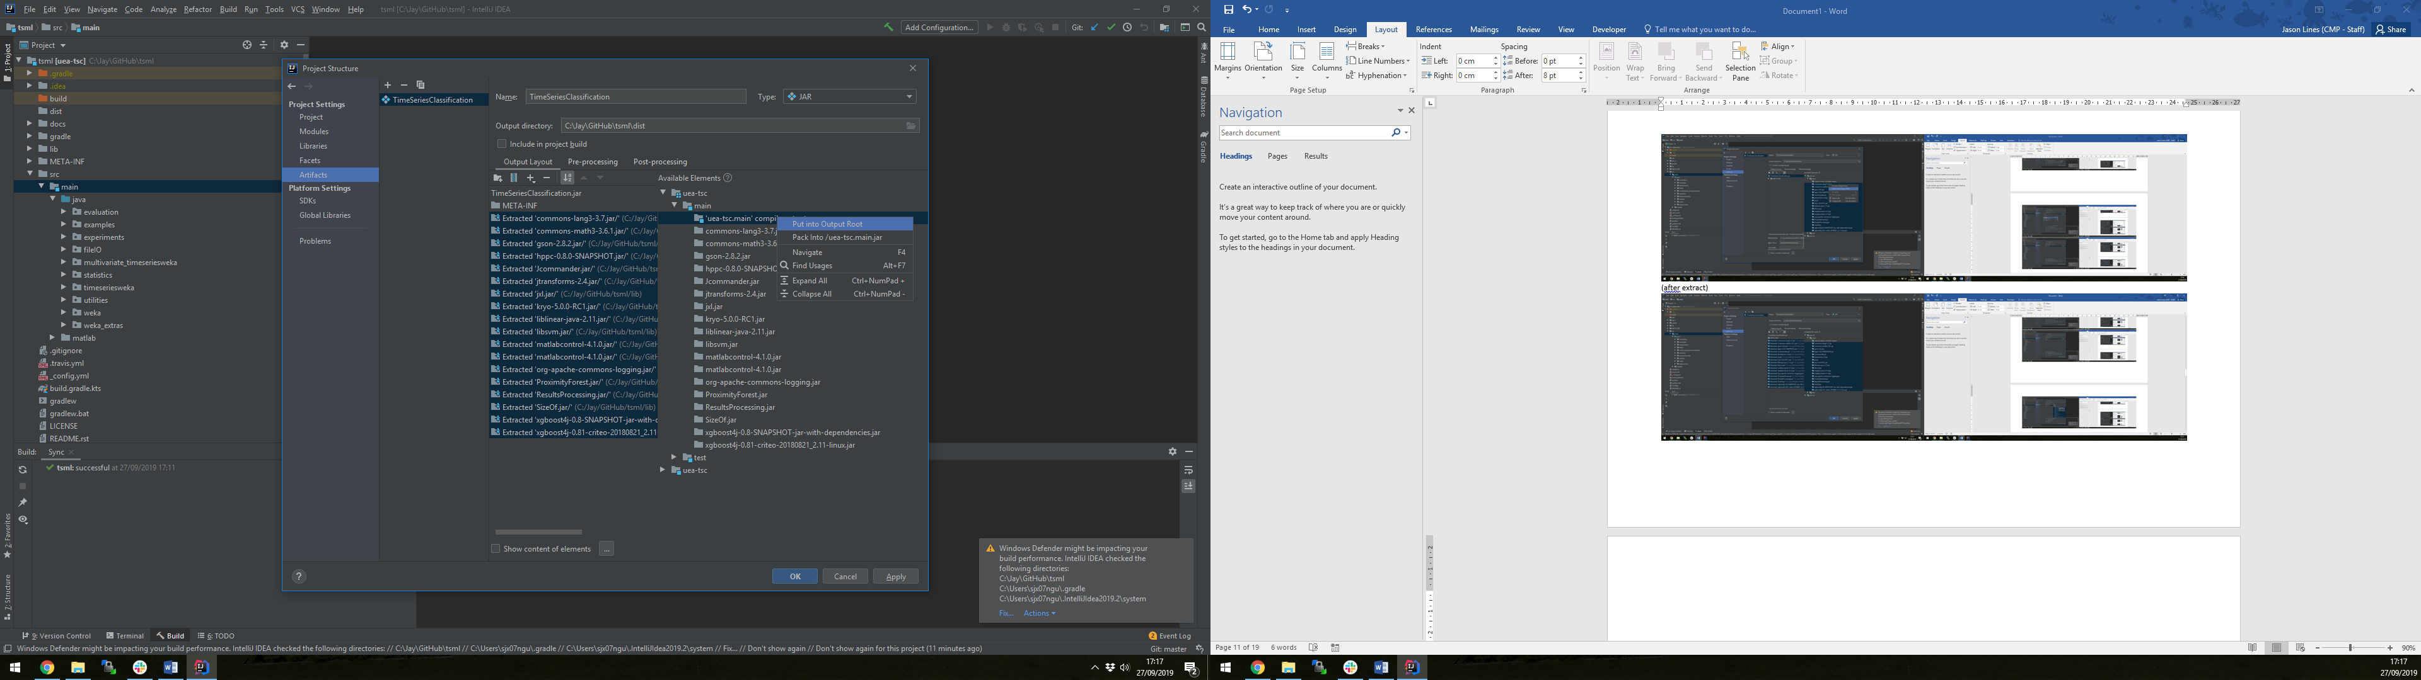

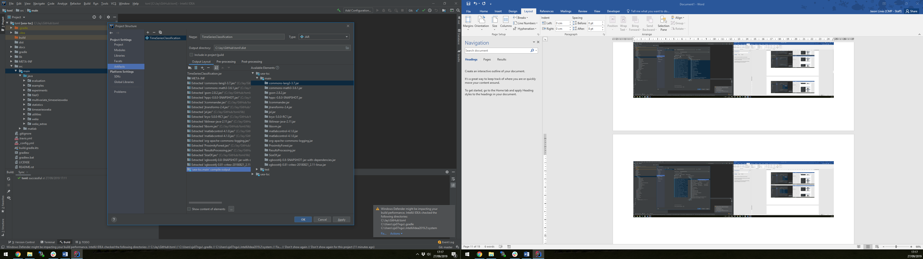

Tick include in project build

->

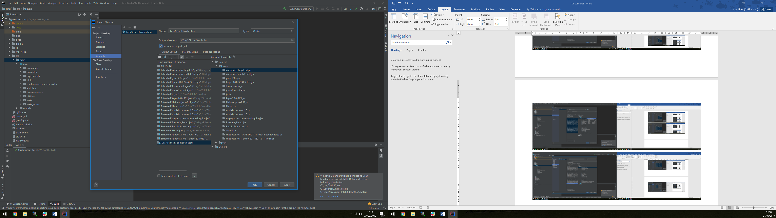

Press OK

